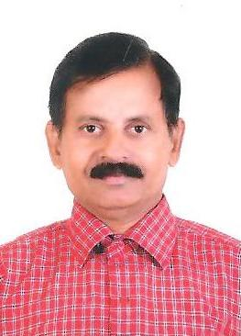

SURENDRAN.P.
Mob :+919995485557 Email: parakkal.surendran@gmail.com

CAREER OBJECTIVE:
To obtain a challenging position with a positive attitude that will fully utilize my skills for the fulfilment of organization goals.Also,to be a part of team that dynamically work towards the growth of organization and gains satisfaction there off.

EDUCATIONAL QUALIFICATION:

- SSLC

EXPERIENCE:
- 1992-2000 :WORKED AS PACKING SUPERVISOR WITH
(8 Years)M/S PACKWAYS PRIVATE LTD,NEW DELHI,
M/S CLINTUS NETWORK LTD, NEW DELHI,
M/S INTEREM LTD. NEW DELHI.

- 2000-2002 :WORKED AS PACKING SUPERVISOR AT
(2 Years)M/S LEADER PACK, SHARJAH

- 2002-2008 :WORKED IN CARGO DELIVERY DEPARTMENT
(6 Years)ARAMEX, DUBAI

- 2008-2010 : WORKED AS CARE TAKER CUM OFFICE ASSISTANT
(2 Years) CHESTERTON INTERNATIONAL, ABU DHABI

- 2010-2017 : WORKED AS PACKING SUPERVISOR WITH M/S ABDUL MUHSEN
SHIPPING LLC, JEBEL ALI, DUBAI

KNOWLEDGE:
- Knowledge in pull out and delivery for pipe,wood and plywood.

PERSONAL INFORMATION:
Nationality : Indian
DOB : 29-04-1960
Sex : Male
Marital Status : Married
Passport : G5039991
Visa status : visa cancelled
Address for Correspondence(Present) :
Surendran.P.
Parakkal sopanam, Post Padur
Via- kavassery, pàlghat dist,
Pin 678543, kerala
+91 999 548 5557
Email parakkal.surendran@gmail.com.

LANGUAGE PROFICIENCY:

LANGUAGE |  |  |  |  |  | Read | Write |  | Speak
 |  |  | ENGLISH |  |  | YES | YES | YES
 |  | MALAYALAM |  |  |  | YES | YES |  | YES
 |  | HINDI |  |  |  | YES | YES |  | YES
 | TAMIL |  |  |  |  | NO | NO | YES

DECLARATION:

I hereby declare that all the information given above is true to the best of my knowledge.

Place: Padur
Date: SURENDRAN.P.

